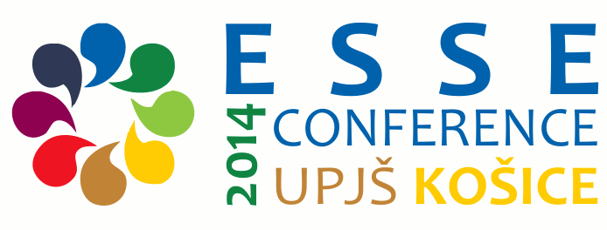
12th ESSE CONFERENCE in KOŠICE, SLOVAKIA
Friday 29 August – Tuesday 2 September, 2014
Organised by Pavol Jozef Šafárik University in Košice, Slovakia
Department of British and American Studies, Faculty of Arts
and
SKASE (The Slovak Association for the Study of English)
To be held at P. J. Šafárik University in Košice, Šrobárova 2, Košice
http://kaa.ff.upjs.sk/en/event/4/12th-esse-conference
Seminar SLANG 32
English as a Foreign Language for Students with Special Educational Needs – Exceptional English for Exceptional Learners?
Convenors: Ewa Domagala-Zysk, Edit H. Kontra
Abstracts
Edit H. Kontra, Piniel Katalin, Csizér Kata, Eötvös Loránd University, Budapest, Hungary
Foreign language teachers at schools for the hearing impaired download
Ewa Domagała-Zyśk, John Paul II Catholic University of Lublin, Poland
Teaching English as a foreign language to the deaf and hard of hearing adult learners of different educational backgrounds download
Nuzha Moritz, University of Strasbourg, France
Oral communication and intelligibility in deaf speech download
Patricia Pritchard, Senior advisor, Statped vest, Bergen, Norway
English education for deaf pupils in Norway download
Anna Podlewska, John Paul II Catholic University of Lublin, Poland
The use of cued speech to support development of language skills in English language instruction for students with hearing impairments download
Anna Nabiałek, Adam Mickiewicz University, Poznan, Poland
Immersion in the language download
Joanna Falkowska, Faculty of English, Adam Mickiewicz University, Poznan, Poland
Monolingual, bilingual, trilingual – what should an EFL class for the D/deaf look like? download
Zuzana Fonioková, Teiresias Centre for Students with Special Needs, Masaryk University, Brno, Czech Republic
English for learners with hearing impairments: Challenges in written output download
Jitka Sedláčková, English Department, Faculty of Education, Masaryk University, Brno, Czech Republic
Teaching reading strategies to deaf learners in the English classroom download
Monika Malec, Institute of Pedagogy, John Paul II Catholic University of Lublin, Poland
Lesson content modifications: how to adapt ESL teaching strategies to the special needs of deaf and hard-of-hearing students download
Marta Dick-Bursztyn, Rzeszów University, Poland
Enhancing memory processes and information organisation in teaching English vocabulary to deaf and HOH students by the application of mnemonic devices download

